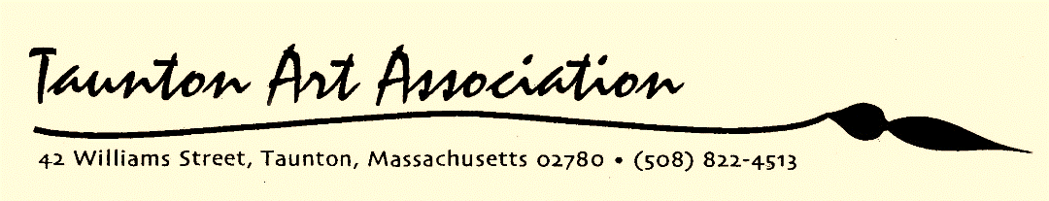



Website: [www.tauntonarts.org](http://www.tauntonarts.org) Email: [tauntonarts@live.com](mailto:tauntonarts@live.com)



April 2017



The Taunton Art Association is supported in part by a grant from the Taunton Cultural Council, a local agency which is supported by the Massachusetts Cultural Council, a state agency.



1.

Calendar of Events

**2017 SPRING ART SHOW REGISTRATION FORM**

**Please Print**

Name:_____________________________________Address:_______________________________

Town:_______________________________________State:___________Zip Code:____________

Phone:_____________________Cell:___________________Email:__________________________

**\*Entry Fee**: Members $6 per piece / Non-members $8 per piece.

**\*Sale of Artwork**: The Taunton Art Association collects 25% commission on any sales.

**\*Requirements**: Submitted entries should be original, completed within the last 3 years, and not submitted in previous TAA shows. All work must be framed and ready to hang. **Any entries with sawtooth hangars will not be accepted**. Watercolors and Pastels must be under glass. Artists will be limited to one award per category.

**\*Disclaimer**: All artists’ entries will be handled with all possible care, but TAA and their officers and volunteers will not be responsible for loss, theft, or damage for any cause. Work is submitted at the risk of the artist and registration indicates acceptance of all the above conditions.

**\*Artist’s Signature**:__________________________________________________________Date:_________

Please list the Title, Medium, and Price**. Do not number**. Write **NFS** for NOT FOR SALE or **POR** for PRICE ON REQUEST.

______Title:_______________________________________________Medium:__________________$_______

______Title:_______________________________________________Medium:__________________$_______

______Title:_______________________________________________Medium:__________________$_______

______Title:_______________________________________________Medium:__________________$_______

**For Office Use Only**

# of Paintings:______Membership:______Member / Non-Member (circle)Paid: Cash_____ Check #________

PLEASE FILL IN THE LABELS BELOW AND AFFIX TO THE BACK OF EACH PAINTING

**NAME________________________________________________________PHONE________________________**

**TITLE_________________________________________________________MEDIUM_____________________**

**……………………………………………………………………………………………………………………………………….**

**NAME_________________________________________________________PHONE______________________**

**TITLE_________________________________________________________MEDIUM________________________**

**THURSDAYS, APRIL 6 & 20, 6:00 – 8:00 PM**

Color Your World

Free adult coloring book nights,

Enjoy a night out with coloring enthusiasts!

**WEDNESDAY, APRIL 19, 7:00 PM**

Oil landscape demonstration with Ted Charron

**WEDNESDAY, APRIL 26, 6:30 PM**

Board of Directors Meeting

**FRIDAY, APRIL 28: 6:00 PM – 8:00 PM**

**SATURDAY, APRIL 29: 10:00 AM – 12:00 PM**

Spring Art Show Registration

**SUNDAY, MAY 7: 1:00 PM – 4:00 PM**

Spring Art Show

Awards ceremony 3:30 pm

April Class Schedule

**SATURDAYS, 10:00 AM – 1:00 PM**

Drawing and Oil Painting with Matt Miller

**MONDAYS, 6:30 PM – 9:00 PM**

Acrylic Decorative Painting with Sue Boerman

Open Paint Night: No teacher, just artists helping and encouraging each other in a relaxed atmosphere.

There is a small $5 fee for use of the building.

**FRIDAYS, 10:30 AM – 1:00 PM**

Acrylic Decorative Painting with Sue Boerman

1.

6.

Acrylic Paint & Pour Workshop

with Debbie Johnson

Ted Charron

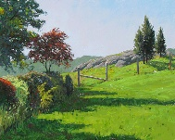

Date: Sunday, April 30, 2017

Time: 1:00 pm – 4:00 pm

Cost: $35 members / $40 non-members

All materials included

Join Debbie as she shows you the latest acrylic painting technique; Fluid Painting. Learn how to do a dirty pour and pour your own masterpiece! No paint brushes needed or previous experience with acrylics. All materials supplied.

Please make check payable to TAA and send along with form

below to:

Debbie Johnson

321 S. Worcester Street,

Norton, MA 02766

Have any questions? Please contact Debbie at 774-297-1395.

*************************************************************************

NAME__________________________________________________________________

ADDRESS_______________________________________________________________

CITY/TOWN______________________________________________STATE________

PHONE_________________________________CELL___________________________

EMAIL___________________________________________________________________

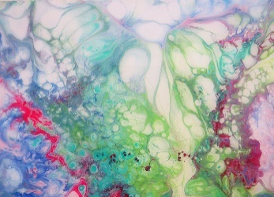

On Wednesday, April 19, at 7:00 pm, TAA will welcome oil painter Ted Charron as our guest demonstrator.

Ted is a native New Englander born in Rhode Island and brought up in South Attleboro, MA. He studied with Norman Baer, Walter Marks, and Murray Wentworth at the Art Institute of Boston. He also had additional studies in sculpture at Providence College.

Other prominent artists he studied under are portrait artist Daniel E. Greene, Canadian wildlife artist Robert Bateman, watercolorist Nita Engle and Boston School senior member Robert Douglas Hunter.

Ted has received over 100 awards, belongs to many art societies, and has his artwork in permanent collections of museums and other public and private collections worldwide. He has conducted workshop classes and painting and drawing demonstrations for over 30 years.

Please visit Ted’s website at www.tacharron.com.

5.

2.

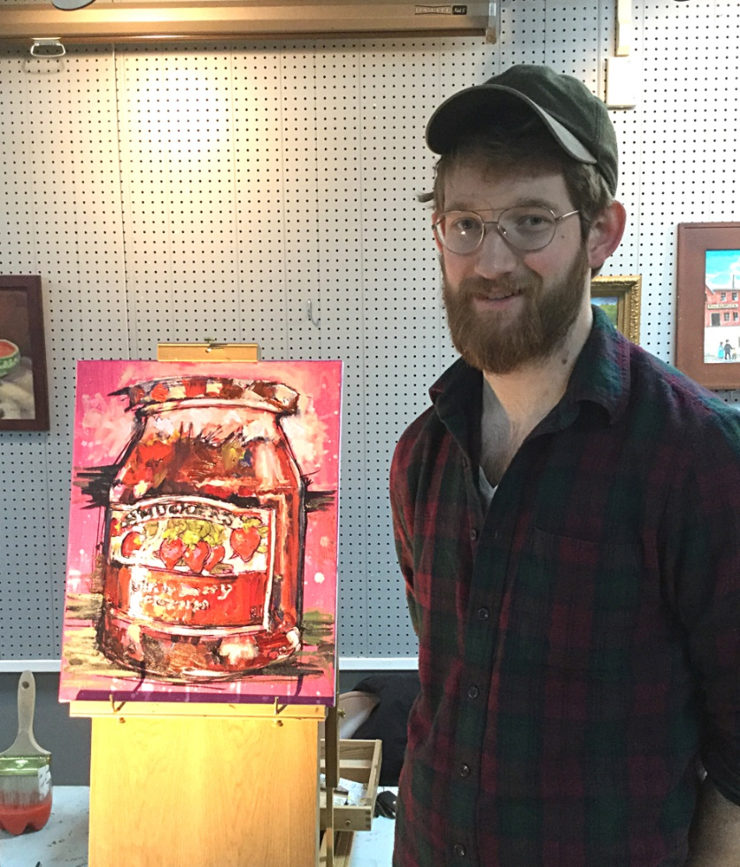

March Demo

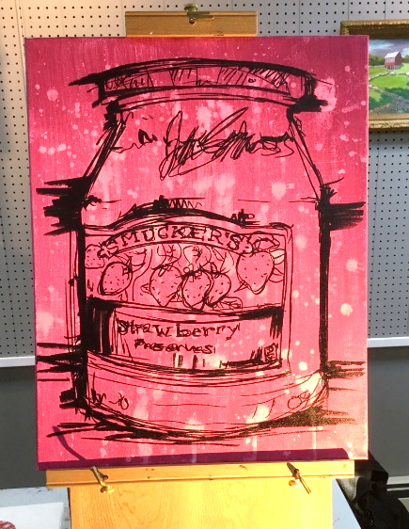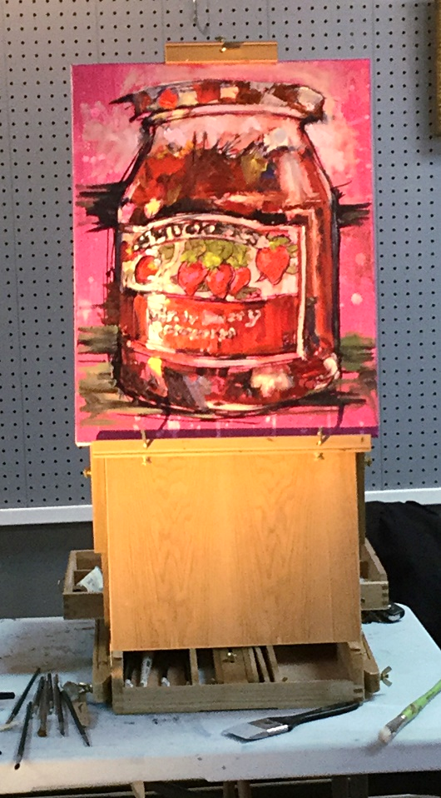

4.

3.

Above: The underpainting.

Right: Finished painting. The dark handled brush across the front of the easel is the color shaper tool.

Our March demonstration with John Davis was great! John takes everyday objects, blows them up, and makes them colorful and fun.

The object for the demo was an ordinary jar of Smuckers strawberry preserves. The canvas came prepped with a fuchsia acrylic background and the jar was drawn in with a black Chartpak paint marker.

John started painting in the brightest areas first with Zinc White. Those areas were painted quite thick. The next to be painted were the areas that caught the ambient light. Then the darkest darks were added. After that the rest of the colors were laid in. Once he got to the lettering he explained that the legibility of the letters weren’t as important as the color and design.

One or two brushes were used throughout the painting process, although John stated that he often uses one brush so that some of the colors blend together throughout the process. Another tool used was a silicone color shaper, which can remove excess paint or thin it out. They come in different sizes and are shaped like brushes.

John uses many brands of oil paint but his favorites are Holbein, Gamblin, and Winsor Newton.